PART 1

Import Clients

LOAD CSV WITH HEADERS FROM 'file:///clients.csv' AS row
CREATE (:Client {
id: row.id,
name: row.name,
email: row.email,
phone: row.phone,
tfn: row.tfn,
flagged: row.flagged
});

Import Stores
LOAD CSV WITH HEADERS FROM 'file:///stores.csv' AS row
CREATE (:Store {
id: row.id,
name: row.name
});

Verify IDs existing
MATCH (c:Client) RETURN c.id, c.name LIMIT 5;
MATCH (s:Store) RETURN s.id, s.name LIMIT 5;

Relationship creation query
LOAD CSV WITH HEADERS FROM 'file:///purchase.csv' AS row
MATCH (c:Client {id: row.idFrom})
MATCH (s:Store {id: row.idTo})
CREATE (c)-[:PURCHASED {
amount: toFloat(row.amount),
timeOffset: toInteger(row.timeOffset)
}]->(s);

Check the relationships (Connections between Clients and Stores)
MATCH ()-[r:PURCHASED]->() RETURN r LIMIT 10;

(Client → Client) Transfer Relationships
LOAD CSV WITH HEADERS FROM 'file:///xfer.csv' AS row
MATCH (sender:Client {id: row.idFrom})
MATCH (receiver:Client {id: row.idTo})
CREATE (sender)-[:TRANSFERRED_TO {
amount: toFloat(row.amount),
timeOffset: toInteger(row.timeOffset)
}]->(receiver);

Confirm transfers created
MATCH ()-[r:TRANSFERRED_TO]->() RETURN r LIMIT 10;

Check total relationship summary
MATCH ()-[r]->() RETURN DISTINCT type(r), count(*) LIMIT 10;
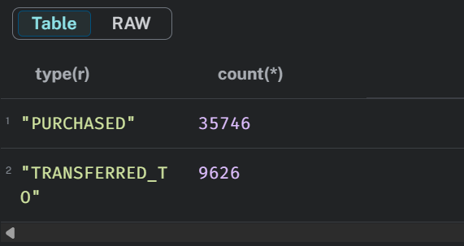

Visualize the full network
MATCH (a)-[r]->(b)
RETURN a.name AS From, type(r) AS Relationship, b.name AS To, r.amount AS Amount
LIMIT 50;

PURCHASED and TRANSFERRED_TO
LOAD CSV WITH HEADERS FROM 'file:///purchase.csv' AS row
MATCH (c:Client {id: row.idFrom})
MATCH (s:Store {id: row.idTo})
CREATE (t:Transaction:Purchase {
txn_id: apoc.create.uuid(),
amount: toFloat(row.amount),
timestamp: datetime({epochMillis: toInteger(row.timeOffset)}),
hour: toInteger(apoc.date.format(toInteger(row.timeOffset), 's', 'H')),
weekday: apoc.date.format(toInteger(row.timeOffset), 's', 'EEE'),
business_hours:
CASE
WHEN toInteger(apoc.date.format(toInteger(row.timeOffset), 's', 'H')) >= 9
AND toInteger(apoc.date.format(toInteger(row.timeOffset), 's', 'H')) <= 17
THEN true
ELSE false
END
})
CREATE (c)-[:MADE]->(t)
CREATE (t)-[:AT_STORE]->(s);

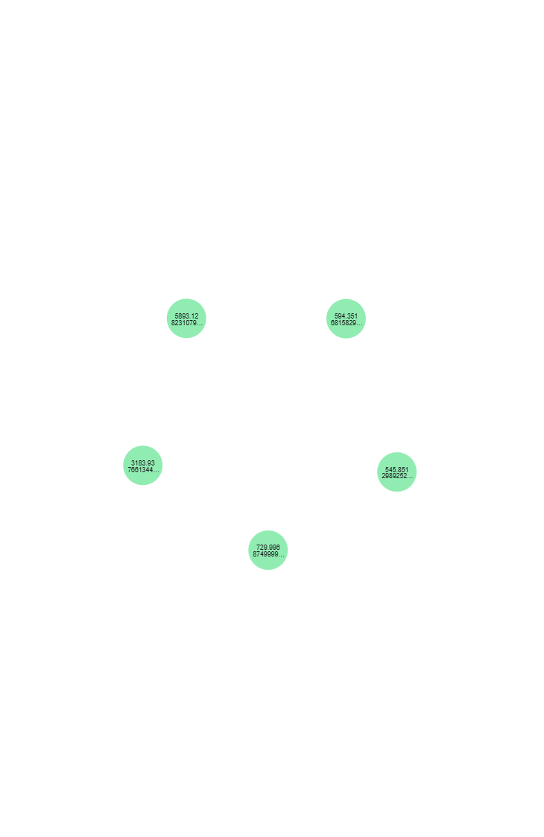
Create Transfer Transactions
LOAD CSV WITH HEADERS FROM 'file:///xfer.csv' AS row
MATCH (sender:Client {id: row.idFrom})
MATCH (receiver:Client {id: row.idTo})
CREATE (t:Transaction:Transfer {
txn_id: apoc.create.uuid(),
amount: toFloat(row.amount),
timestamp: datetime({epochMillis: toInteger(row.timeOffset)}),
hour: toInteger(apoc.date.format(toInteger(row.timeOffset), 's', 'H')),
weekday: apoc.date.format(toInteger(row.timeOffset), 's', 'EEE'),
business_hours:
CASE
WHEN toInteger(apoc.date.format(toInteger(row.timeOffset), 's', 'H')) >= 9
AND toInteger(apoc.date.format(toInteger(row.timeOffset), 's', 'H')) <= 17
THEN true
ELSE false
END
})
CREATE (sender)-[:SENT]->(t)
CREATE (t)-[:TO]->(receiver);

// Check one transfer transaction
MATCH (t:Transaction:Transfer) RETURN t LIMIT 5;

// See sample edges
MATCH (a:Client)-[r:SENT]->(t:Transfer)-[:TO]->(b:Client)
RETURN a.name AS Sender, b.name AS Receiver, t.amount AS Amount, t.business_hours AS BusinessHours
LIMIT 10;

NEXT_TXN_OF relationships
// represent transaction sequences per client
MATCH (c:Client)-[:MADE|:SENT]->(t:Transaction)
WITH c, t ORDER BY t.timestamp
WITH c, collect(t) AS txns
UNWIND range(0, size(txns)-2) AS i
WITH txns[i] AS t1, txns[i+1] AS t2, c
MERGE (t1)-[:NEXT_TXN_OF {client_id: c.id}]->(t2);
SIMILAR_TO between clients
MATCH (c1:Client)
WITH c1
MATCH (c2:Client)
WHERE c1.tfn = c2.tfn OR c1.email = c2.email
AND c1 <> c2
MERGE (c1)-[:SIMILAR_TO]->(c2);

Add :Source Nodes and Link to Transactions
// Create Source nodes
MERGE (s1:Source {name:'purchase.csv'})
MERGE (s2:Source {name:'xfer.csv'});

// Link Purchase transactions to their source
MATCH (t:Purchase), (s:Source {name:'purchase.csv'})
MERGE (t)-[:FROM_SOURCE]->(s);

// Link Transfer transactions to their source
MATCH (t:Transfer), (s:Source {name:'xfer.csv'})
MERGE (t)-[:FROM_SOURCE]->(s);

Add Constraints and Indexes (for Scalability and Integrity)
// Ensure unique IDs for Clients, Stores, and Transactions
CREATE CONSTRAINT unique_client_id IF NOT EXISTS
FOR (c:Client) REQUIRE c.id IS UNIQUE;

CREATE CONSTRAINT unique_store_id IF NOT EXISTS
FOR (s:Store) REQUIRE s.id IS UNIQUE;

CREATE CONSTRAINT unique_txn_id IF NOT EXISTS
FOR (t:Transaction) REQUIRE t.txn_id IS UNIQUE;

// Add indexes for frequently filtered or joined fields
CREATE INDEX client_email_index IF NOT EXISTS FOR (c:Client) ON (c.email);
CREATE INDEX client_tfn_index IF NOT EXISTS FOR (c:Client) ON (c.tfn);
CREATE INDEX txn_timestamp_index IF NOT EXISTS FOR (t:Transaction) ON (t.timestamp);
CREATE INDEX store_name_index IF NOT EXISTS FOR (s:Store) ON (s.name);
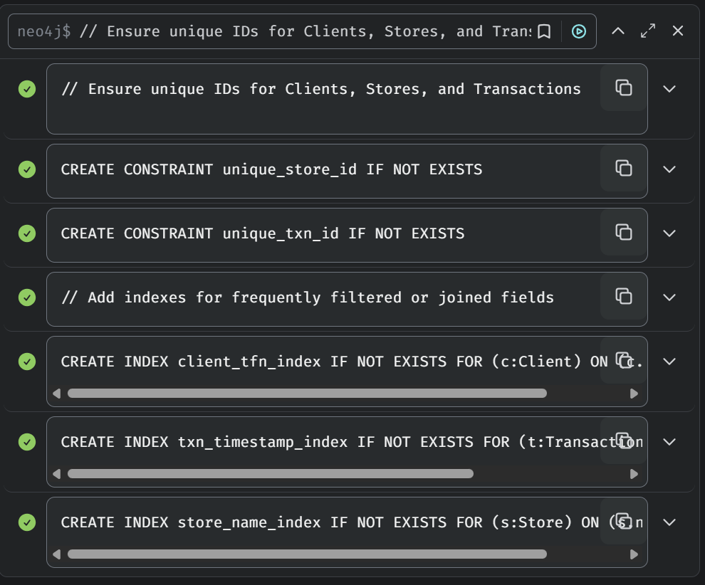

To compare query performance with and without indexes:
// Without Index
DROP INDEX txn_timestamp_index;
PROFILE MATCH (t:Transaction) WHERE t.timestamp >= datetime('2025-01-01') RETURN count(t);

// With Index
CREATE INDEX txn_timestamp_index IF NOT EXISTS FOR (t:Transaction) ON (t.timestamp);
PROFILE MATCH (t:Transaction) WHERE t.timestamp >= datetime('2025-01-01') RETURN count(t);

Explanation

The payments graph was designed for scalability, query efficiency, and extensibility in future fraud-detection research.
1. Modeling Extensions
Two new relationship types were added:
- NEXT_TXN_OF links each client’s consecutive transactions in time, supporting temporal sequence modeling (e.g., bursts of small transfers before a large fraud).
- SIMILAR_TO connects clients sharing TFNs or emails, revealing potential collusion, duplicate accounts, or household clusters.
Both relationships enable higher-level pattern detection through Neo4j Graph Data Science algorithms .
2. Temporal Representation
The original timeOffset was converted to a datetime field (timestamp) with derived features such as hour, weekday, and business_hours. This supports fraud behaviour rules.
3. Constraints and Indexes
Unique constraints on IDs for Client, Store, and Transaction guarantee entity integrity across imports. Indexes on email, tfn, and timestamp reduce lookup costs for similarity joins and temporal aggregation queries.
4. Data Integrity and Provenance
Each dataset (purchase.csv, xfer.csv) was represented by a Source node connected via FROM_SOURCE relationships to its transactions. This design preserves data provenance, allowing auditing and multi-source expansion without schema changes.
5. Extensibility
Both Purchase and Transfer are modeled as sub-types of Transaction, allowing future types like Refund, Loan, or CryptoTransfer to reuse the same structure.

PART 2

Problem 1:
Top Spenders Between a Time Window
// ----- PARAMETERS -----
:param startTime => datetime("2024-05-12T10:00:00+10:00");
:param endTime => datetime("2024-05-12T14:00:00+10:00");

// ----- QUERY -----
MATCH (c:Client)-[:MADE]->(p:Purchase)-[:AT_STORE]->(s:Store)
WHERE p.timestamp >= $startTime
AND p.timestamp < $endTime
AND p.amount > 0
WITH
c.name AS name,
s.name AS store,
SUM(p.amount) AS total_spent,
COUNT(p) AS txn_count,
MIN(p.timestamp) AS first_txn_time,
MAX(p.timestamp) AS last_txn_time
WITH
name,
COLLECT({
store: store,
total_spent: total_spent
}) AS store_spends,
SUM(total_spent) AS total_in_window,
SUM(txn_count) AS txn_count,
MIN(first_txn_time) AS first_txn_time,
MAX(last_txn_time) AS last_txn_time
// Identify each client's top store
WITH name, total_in_window, txn_count, first_txn_time, last_txn_time,
REDUCE(topStore = {store: null, spend: 0}, ss IN store_spends |
CASE WHEN ss.total_spent > topStore.spend
THEN {store: ss.store, spend: ss.total_spent}
ELSE topStore END
) AS top_store_data
WITH
name,
total_in_window,
txn_count,
first_txn_time,
last_txn_time,
top_store_data.store AS top_store,
top_store_data.spend AS top_store_spend
ORDER BY total_in_window DESC

// ----- Manual Dense Rank -----
WITH COLLECT({
name: name,
total_in_window: total_in_window,
txn_count: txn_count,
first_txn_time: first_txn_time,
last_txn_time: last_txn_time,
top_store: top_store,
top_store_spend: top_store_spend
}) AS clientData

WITH clientData,
[x IN clientData | x.total_in_window] AS totals,
apoc.coll.toSet([x IN clientData | x.total_in_window]) AS uniqueTotals
UNWIND clientData AS row
WITH row,
apoc.coll.indexOf(uniqueTotals, row.total_in_window) + 1 AS rank
WHERE rank = 1 // <-- change to <= 5 if you want the top 5
RETURN
row.name AS name,
row.total_in_window AS total_in_window,
row.txn_count AS txn_count,
row.first_txn_time AS first_txn_time,
row.last_txn_time AS last_txn_time,
row.top_store AS top_store,
row.top_store_spend AS top_store_spend,
rank
ORDER BY rank ASC, name;

Problem 2:
Top Clients with Largest Negative Cash Flow
// --------- PROBLEM 2: Negative Cashflow Clients ---------

// Step 1: calculate all outgoing money (Purchases + Transfers sent)
MATCH (c:Client)
OPTIONAL MATCH (c)-[:MADE]->(p:Purchase)
WITH c, COALESCE(SUM(p.amount), 0) AS total_purchases

OPTIONAL MATCH (c)-[:TRANSFERRED_TO]->(receiver:Client)
WITH c, total_purchases, COALESCE(SUM(receiver.amount), 0) AS total_transfers_sent

// Step 2: calculate all incoming transfers
OPTIONAL MATCH (sender:Client)-[r:TRANSFERRED_TO]->(c)
WITH c,
total_purchases,
total_transfers_sent,
COALESCE(SUM(r.amount), 0) AS total_transfers_received

// Step 3: compute cashflow metrics
WITH
c.name AS name,
(total_purchases + total_transfers_sent) AS total_outgoing,
total_transfers_received AS total_incoming,
(total_transfers_received - (total_purchases + total_transfers_sent)) AS balance,
CASE
WHEN total_purchases >= total_transfers_sent THEN total_purchases
ELSE total_transfers_sent
END AS max_outgoing

// Step 4: count all relationships (transaction volume)
OPTIONAL MATCH (c)-[tx]->()
WITH
name,
total_outgoing,
total_incoming,
balance,
max_outgoing,
COUNT(tx) AS txn_count
ORDER BY balance ASC
LIMIT 20 // <-- safety limit to keep memory low

// Step 5: rank manually (no OVER)
WITH COLLECT({
name:name,
balance:balance,
max_outgoing:max_outgoing,
total_outgoing:total_outgoing,
total_incoming:total_incoming,
txn_count:txn_count
}) AS data

UNWIND range(0, size(data)-1) AS i
WITH data[i] AS row, i+1 AS rank
WHERE rank <= 5
RETURN
row.name AS name,
row.balance AS balance,
row.max_outgoing AS max_outgoing,
row.total_outgoing AS total_outgoing,
row.total_incoming AS total_incoming,
row.txn_count AS txn_count,
rank
ORDER BY rank ASC, name;

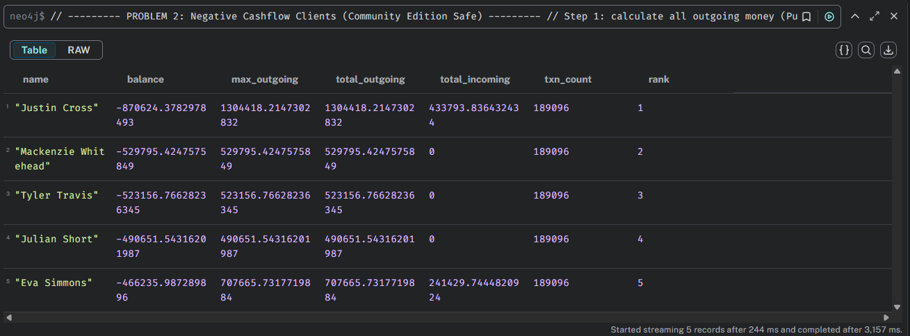

Problem 3 :
Detect “Pass-Through” Clients

// --------- PROBLEM 3: Pass-Through Funds Detection (Community Edition Safe - No APOC) ---------

:param sellerName => "Woods";
:param lookbackHours => 48;

// 1️⃣ Find the suspicious seller node
MATCH (targetSeller:Store)
WHERE toLower(targetSeller.name) CONTAINS toLower($sellerName)

// 2️⃣ Find all purchases at that seller
MATCH (client:Client)-[p:MADE]->(txn:Purchase)-[:AT_STORE]->(targetSeller)
WHERE txn.amount > 0

// 3️⃣ For each purchase, look back for incoming transfers within the window
OPTIONAL MATCH (sender:Client)-[xfer:TRANSFERRED_TO]->(client)
WHERE xfer.amount > 0
AND xfer.timestamp < txn.timestamp
AND duration.between(xfer.timestamp, txn.timestamp).hours <= $lookbackHours
AND sender <> client // avoid self-funding

// 4️⃣ Aggregate and calculate top sender manually
WITH client.name AS name,
COLLECT(DISTINCT sender.name) AS senders,
COUNT(DISTINCT sender) AS n_senders,
SUM(DISTINCT xfer.amount) AS attributed_xfer,
SUM(DISTINCT txn.amount) AS total_purchase,
MIN(txn.timestamp) AS first_purchase_time,
// manually find the largest transfer amount
REDUCE(maxAmt = 0.0, s IN COLLECT(xfer.amount) |
CASE WHEN s > maxAmt THEN s ELSE maxAmt END) AS top_sender_amount

// Find the sender corresponding to that max amount
OPTIONAL MATCH (sender2:Client)-[xfer2:TRANSFERRED_TO]->(client)
WHERE xfer2.amount = top_sender_amount
WITH
name,
senders,
n_senders,
attributed_xfer,
total_purchase,
first_purchase_time,
sender2.name AS top_sender,
top_sender_amount

// 5️⃣ Compute percentage and filter suspicious clients
WITH name,
total_purchase,
attributed_xfer,
n_senders,
first_purchase_time,
top_sender,
top_sender_amount,
CASE
WHEN attributed_xfer > 0 THEN (total_purchase / attributed_xfer) * 100
ELSE 0
END AS percentage
WHERE percentage >= 5 AND total_purchase > 0 AND n_senders >= 1

// 6️⃣ Return final report
RETURN
name,
round(percentage,2) AS percentage,
round(attributed_xfer,2) AS attributed_xfer,
round(total_purchase,2) AS total_purchase,
first_purchase_time,
n_senders,
top_sender,
round(top_sender_amount,2) AS top_sender_amount
ORDER BY percentage DESC, total_purchase DESC
LIMIT 20;

Problem 4 :
Temporal Transaction Ordering

// --------- PROBLEM 4: Temporal Transaction Ordering ---------

// 1️⃣ Collect all transactions per client (Purchase + Transfer)
MATCH (c:Client)
OPTIONAL MATCH (c)-[:MADE]->(p:Purchase)
OPTIONAL MATCH (c)-[:TRANSFERRED_TO]->(t1:Transaction)
OPTIONAL MATCH (c)<-[:TRANSFERRED_TO]-(t2:Transaction)
WITH c, collect(p) + collect(t1) + collect(t2) AS txns
WHERE size(txns) > 1

// 2️⃣ Order transactions by timestamp
UNWIND txns AS t
WITH c, t
WHERE t.timestamp IS NOT NULL
ORDER BY c.name, t.timestamp ASC
WITH c, collect(t) AS ordered_txns
WHERE size(ordered_txns) > 1

// 3️⃣ Create consecutive pairs (txn[i] → txn[i+1])
UNWIND range(0, size(ordered_txns)-2) AS i
WITH c, ordered_txns[i] AS txn1, ordered_txns[i+1] AS txn2

// 4️⃣ Create NEXT_TXN_OF relationships
MERGE (txn1)-[:NEXT_TXN_OF {client: c.name}]->(txn2);

PART 3
Problem 1 :
Community Detection (Louvain + Connected Components)

// 🧠 Create projection for community detection
CALL gds.graph.project(
'fraud_graph',
'Client',
{
SIMILAR_TO: {
type: 'SIMILAR_TO',
orientation: 'UNDIRECTED'
}
}
);

Louvain:
CALL gds.louvain.write('fraud_graph', {
writeProperty: 'louvain_group'
})
YIELD communityCount, modularity, modularities;

Connected Components (WCC):
CALL gds.wcc.write('fraud_graph', {
writeProperty: 'component_group'
})
YIELD componentCount, nodePropertiesWritten;
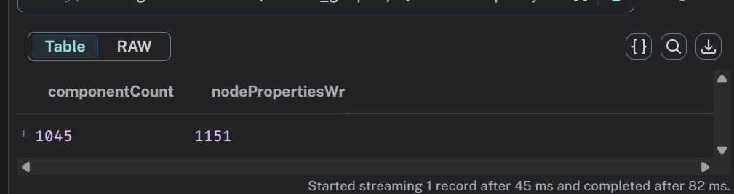

Identify Large Fraud-Like Clusters (≥ 5 members)
// 🧩 Count and label dense clusters
MATCH (c:Client)
WITH c.louvain_group AS group_id, count(*) AS members
WHERE members >= 5
WITH collect(group_id) AS fraud_groups
MATCH (c:Client)
WHERE c.louvain_group IN fraud_groups
SET c:FraudGroup,
c.fraud_group_id = c.louvain_group,
c.detection_method = 'Louvain';

Verify Group Sizes
MATCH (c:FraudGroup)
RETURN c.fraud_group_id AS group_id,
count(*) AS members,
c.detection_method AS method
ORDER BY members DESC
LIMIT 10;
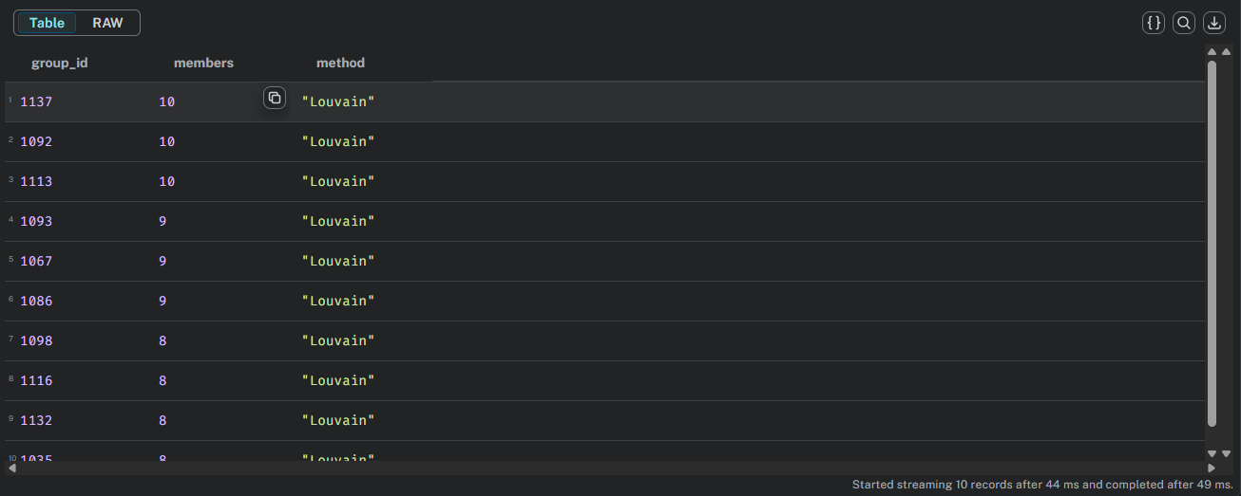

Visualise in Neo4j Browser
MATCH (c:FraudGroup)
RETURN c
LIMIT 100;


Problem 2 :
Identify Cross-Boundary Transactions

MATCH (src:Client)-[t:TRANSFERRED_TO]->(dst:Client)
WHERE src.fraud_group_id IS NOT NULL
AND (dst.fraud_group_id IS NULL OR dst.fraud_group_id <> src.fraud_group_id)
WITH dst.name AS recipient,
collect(DISTINCT src.name) AS senders,
count(DISTINCT src) AS n_senders,
sum(t.amount) AS total_incoming
WHERE total_incoming > 0
RETURN recipient, n_senders, round(total_incoming,2) AS total_incoming
ORDER BY total_incoming DESC
LIMIT 10;
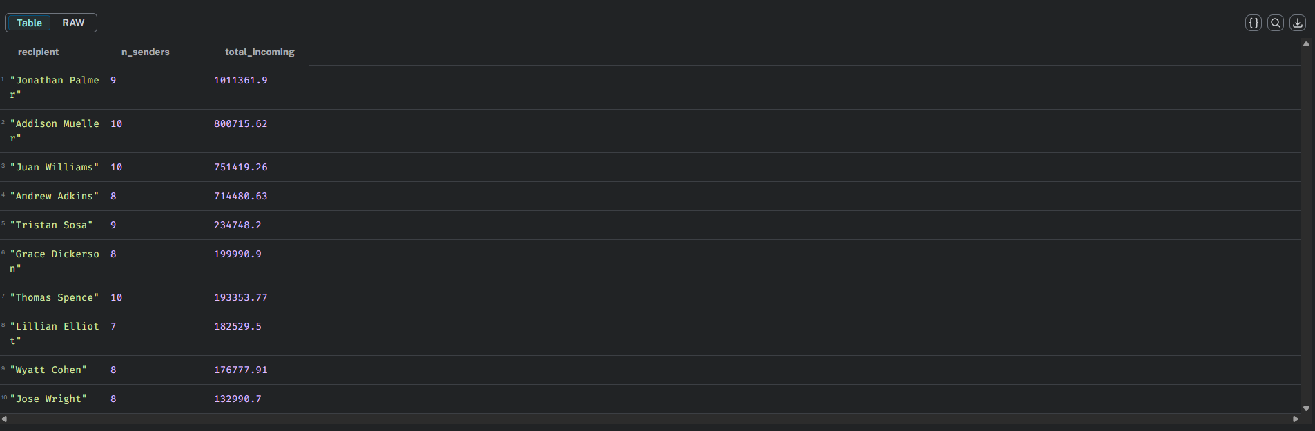

Boundary Subgraph Projection & Clustering
// Safe version — skips relationships with missing endpoints
CALL gds.graph.project.cypher(
'boundary_graph',
'
MATCH (c:Client)
WHERE c.fraud_group_id IS NOT NULL
OR EXISTS {
MATCH (f:Client)-[:TRANSFERRED_TO]->(c)
WHERE f.fraud_group_id IS NOT NULL
}
RETURN id(c) AS id
',
'
MATCH (a:Client)-[r:TRANSFERRED_TO]->(b:Client)
WHERE a.fraud_group_id IS NOT NULL
OR b.fraud_group_id IS NOT NULL
RETURN id(a) AS source, id(b) AS target, r.amount AS amount
',
{ validateRelationships: false } // ✅ Fix: ignore broken links
);
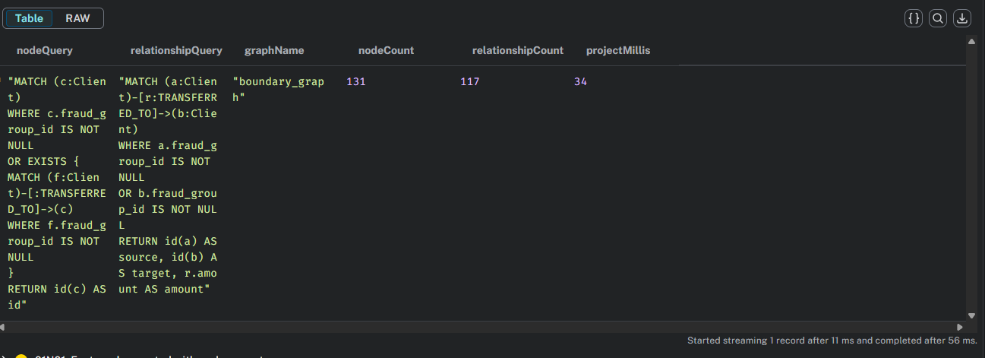

Centrality Analysis on Largest Subset

// Find the largest boundary cluster
MATCH (c:Client)
WHERE c.boundary_cluster IS NOT NULL
WITH c.boundary_cluster AS cluster_id, count(*) AS size
ORDER BY size DESC LIMIT 1

// Project subgraph for that cluster (modern syntax)
WITH cluster_id
CALL {
WITH cluster_id
RETURN gds.graph.project(
'largest_boundary_cluster',
['Client'],
{
TRANSFERRED_TO: {
type: 'TRANSFERRED_TO',
properties: 'amount'
}
},
{
nodeProperties: ['boundary_cluster'],
nodeFilter: 'n.boundary_cluster = $cluster_id',
relationshipFilter: 'r.amount > 0',
parameters: { cluster_id: cluster_id },
validateRelationships: false
}
) AS result
}
YIELD graphName, nodeCount, relationshipCount, projectMillis
RETURN graphName, nodeCount, relationshipCount, projectMillis;

PageRank
CALL gds.pageRank.write('boundary_graph', {
relationshipWeightProperty: 'amount',
writeProperty: 'pagerank_score'
})
YIELD nodePropertiesWritten, configuration, writeMillis, ranIterations, didConverge;

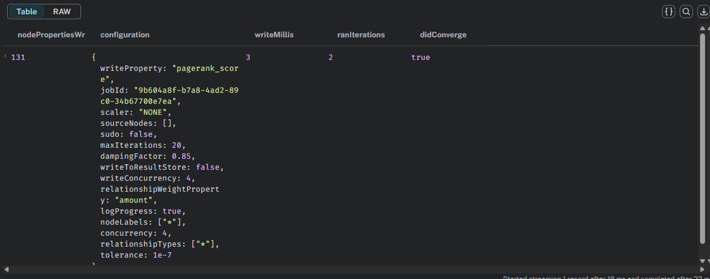

Betweenness Centrality:
CALL gds.betweenness.write('boundary_graph', {
writeProperty: 'betweenness_score'
})
YIELD nodePropertiesWritten, computeMillis;

Compare the results:
// Compare PageRank vs Betweenness
MATCH (c:Client)
WHERE c.pagerank_score IS NOT NULL
AND c.betweenness_score IS NOT NULL
RETURN
c.name AS client,
round(c.pagerank_score, 4) AS pagerank_score,
round(c.betweenness_score, 4) AS betweenness_score
ORDER BY pagerank_score DESC
LIMIT 10;
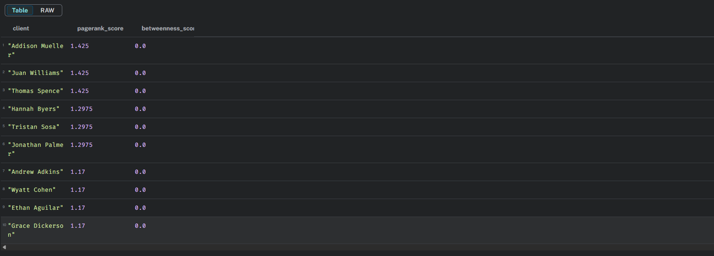
To identify the most influential accounts within the boundary-subgraph, two centrality measures PageRank and Betweenness Centrality were applied using Neo4j GDS 2.22.
The PageRank algorithm measures how frequently a node is reached through weighted incoming links, giving higher scores to accounts that repeatedly receive transactions from other high-value senders. In the fraud-network context, a high PageRank therefore indicates a receiver hub .
In contrast, Betweenness Centrality quantifies how often a node lies on the shortest transaction paths between other clients. Accounts with high betweenness typically serve as brokers or routers, bridging otherwise disconnected clusters and enabling money to circulate while avoiding direct sender-receiver exposure.

Some Screen Shots of my Neo4j

